Hive Installation
Step 1: Download hive-0.14 from the below link by using the browser given in the vm.
Link: https://drive.google.com/file/d/0Bxr27gVaXO5sX3Exbi1Mcnhwdm8/view?usp=sharing
Step 2: Tar file of hive is saved in the Downloads directory
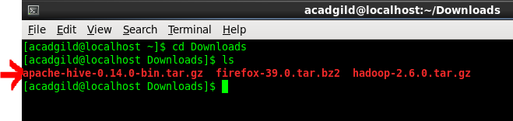
Step 3: create a directory hive_folder in the vm in /home/acadgild directory.
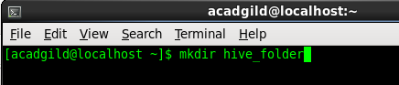
Step 4: Move the tar file of hive to hive_folder directory.

Step 5: untar the tar file of hive using the below command.
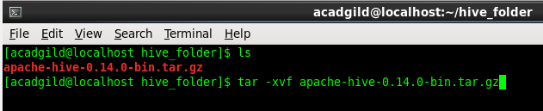
Step 6: Update the .bashrc file with hive path and set the hadoop user class path as true.
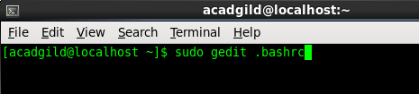

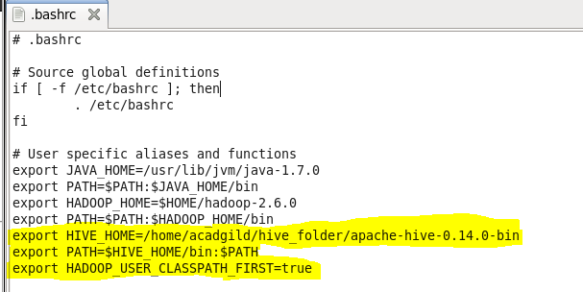

Step 7: Make a directory in hdfs with the path /user/hive/warehouse/ and then change the permissions of the same path and temp directory.
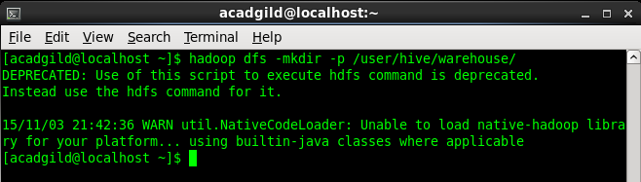
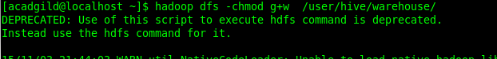

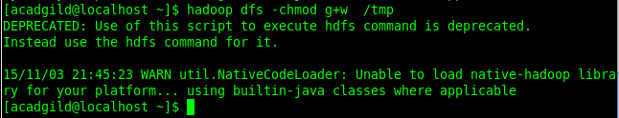

Step 8: Type the command source .bashrc to make hive
Environmental variable active in hadoop cluster.

Step 9: Go to bin directory of apache-hive-0.14.0-bin and update the hadoop path in hive-config.sh file.
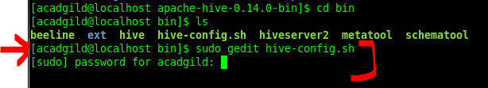
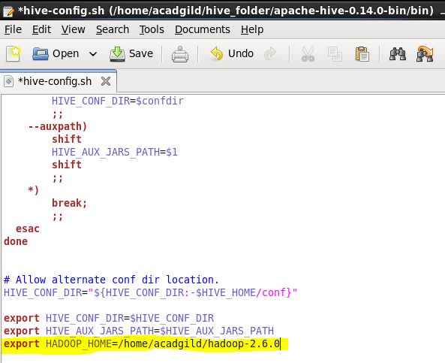

Step 9: Type the command hive to start the hive terminal.
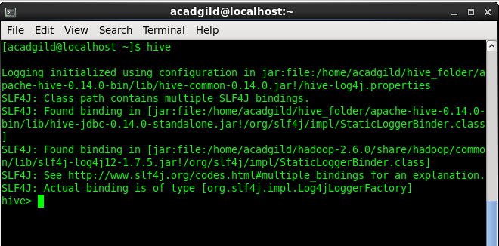

Your Hive is successfully installed!!!!!!

